Mount Sinai to Begin the Transfer of COVID-19 Antibodies into Critically Ill Patients
Mar 24, 2020 | Featured, Infectious Diseases, Research |
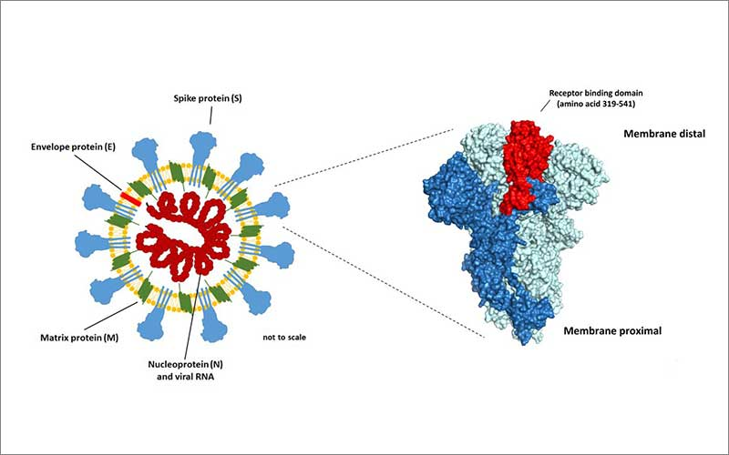
Image from Florian Krammer lab. The main target on the surface of most coronaviruses is the spike protein or S. This is a model of the virus and a visualization of a crystal structure of the spike of SARS-CoV-2.
The Mount Sinai Health System this week plans to initiate a procedure known as plasmapheresis, where the antibodies from patients who have recovered from COVID-19 will be transferred into critically ill patients with the disease, with the expectation that the antibodies will neutralize it.
The process of using antibody-rich plasma from COVID-19 patients to help others was used successfully in China, according to a state-owned organization, which reported that some patients improved within 24 hours, with reduced inflammation and viral loads, and better oxygen levels in the blood.
Mount Sinai is collaborating with the New York Blood Center and the New York State Department of Health’s Wadsworth Center laboratory in Albany, with guidance from the U.S. Food and Drug Administration, and expects to begin implementing the treatment later this week.
“We are hoping to identify patients who can provide the antibodies,” says Dennis S. Charney, MD, Anne and Joel Ehrenkranz Dean of the Icahn School of Medicine at Mount Sinai, and President for Academic Affairs, Mount Sinai Health System. “We are at the front lines in fighting this pandemic and making discoveries that will help our patients.”
Late last week, researchers at the Icahn School of Medicine, in collaboration with scientists in Australia and Finland, were among the first to create an antibody test that detects the disease’s antibodies in a person’s blood. Development of the enzyme-linked immunosorbent assay (ELISA) was led by Florian Krammer, PhD, Professor of Microbiology, in collaboration with Viviana A. Simon, MD, PhD, Professor of Microbiology and Medicine (Infectious Diseases). Dr. Krammer, a renowned influenza researcher, recently made this so-called recipe available to other laboratories around the world so they can replicate it during the pandemic. In January, his lab was quickly retooled to begin studying COVID-19.
In addition to its widespread use in plasmapheresis, the antibody test will provide experts with an accurate infection rate so they can track the trajectory of the disease. The test will help identify health care workers who are already immune to the disease, who can work directly with infectious patients, and it can also help scientists understand how the human immune system reacts to the virus.
The new assay uses recombinant or manufactured antigens from the spike protein on the surface of the SARS-CoV-2 virus. That protein helps the virus enter cells, and it is a key target in the immune reaction against the virus, as the body creates antibodies that recognize the protein and seek to destroy the virus. The researchers also isolated the short piece of the spike protein called the receptor-binding domain (RBD), which the virus uses to attach to cells it tries to invade. The scientists then used cell lines to produce large quantities of the altered spike proteins and RBDs.
According to Dr. Krammer and his co-authors, the assay is “sensitive and specific,” and allows for the screening and identification of COVID-19 in human plasma/serum as soon as three days after the onset of symptoms. The antibodies were derived from three patients who had the disease. The study’s control participants—who did not have COVID-19 but had other viruses, including the common cold—ranged in age from 20 to 70.
Dr. Krammer says his preliminary findings also show that humans have no natural immunity to the SARS-CoV-2 virus, which would help explain why it spreads so quickly. But once the antibody sets in humans do become protected. He also says that at this early stage in the research, there is no evidence that people can lose their immunity and become re-infected.

